

**Name des Kindes**

**Kürzel**

|  |  |  |  |  |  |  |  |  |  |  |  |  |  |  |
| --- | --- | --- | --- | --- | --- | --- | --- | --- | --- | --- | --- | --- | --- | --- |
| **Montag** | | | **Dienstag** | | | **Mittwoch** | | | **Donnerstag** | | | **Freitag** | | |
|  |  |  |  | 95591 | **Knabbermöhre** (MÖ) |  | 95611 | **Knabberkohlrabi** |  | 95601 | **Knabbergurke** |  | 95621 | **Knabberpaprika** (PA) |
|  |  |  |  | 93371 | **Kartoffelbrei** (milchfrei) |  | 95761 | **Gorgonzolasoße Laktfr** (**MP**,ZW) |  | 95831 | **Brokkolisoße** |  | 96131 | **Gemüsesuppe mit Kartoffeln** |
|  |  |  |  | 93711 | **Margarine** |  | 93231 | **Glfr. Spirelli** (ERB)(ERB=Erbsenprotein) |  | 93991 | **Maisherzi** |  | 93551 | **Mehrkornbrötchen** (AP**,LU,SJ,**ZU) |
|  |  |  |  | 94011 | **Currybratling** (CU,KN,MÖ) |  | 95801 | **Spinatsoße** |  | 93131 | **Parboiled Reis** |  | 93071 | **Paprika- Pizza mit Käse** (**MP**,PA,TO,ZU) |
|  | **Pfingstmontag** |  |  | 94071 | **Chicken Nuggets** (ERB,FL) |  | 94181 | **Rinderhackfleisch** (FL) |  | 94331 | **Lachssoße (FI,MP**,ZW) |  | 93081 | **Zucchini-Champignon-Pizza** (1,2,PI,ZU) |
|  |  |  |  | 96081 | **Hirsetopf** (ERB,MÖ,PA) |  | 95211 | **Naturjoghurt** (**MP**) |  | 94131 | **Gebratenes Seelachsfilet** (**FI,SJ**) |  | 93091 | **Paprika-Pizza** (PA,TO,ZU) |
|  |  |  |  | 93831 | **Veganer Pizzastreumix** (1,2) |  | 95151 | **Bananenshake** (FRU) |  | 95311 | **Banane** (FRU) |  | 95221 | **Vanillepudding** |
|  |  |  |  | 94991 | **Schwarz-Weiß-Gebäck** (**MP**,ZU) |  | 96631 | **Reiswaffel** |  | 95341 | **Honigmelone** (FRU) |  | 96451 | **Lakt.fr. Quarkspeise (MP)** (fructosearm) |
|  |  |  |  | 95361 | **Weintrauben** (FRU) |  |  |  |  | 94901 | **Reis-Kokos-Keks** (fructosefrei) |  | 96461 | **Laktfr. Pudding** (1,**MP**,ZU) |
|  |  |  |  | 95311 | **Banane** (FRU) |  |  |  |  |  |  |  |  |  |
|  |  |  |  | 94981 | **Herzkekse** (fructosefrei) |  |  |  |  |  |  |  |  |  |
|  |  |  |  |  |  |  |  |  |  |  |  |  |  |  |
|  |  |  |  |  | Veg. Alternative |  |  | Veg. Alternative |  |  | Veg. Alternative |  |  |  |
|  |  |  |  | 94301 | **Veg. Bratwurst** (1,**WE,EI,SJ**,ERB,GL,KN,MN,ZI,ZW) |  | 95741 | **Spinatsoße** (**WE,MP**, GL,KN,LK,MN,ZW) |  | 94321 | **Veg. Bällchen** (**WE, GER,SJ,SF**,GL,KN,ZI,ZW)  **dazu Tomatensoße** (KN,TO,ZI,ZU,ZW) |  |  |  |

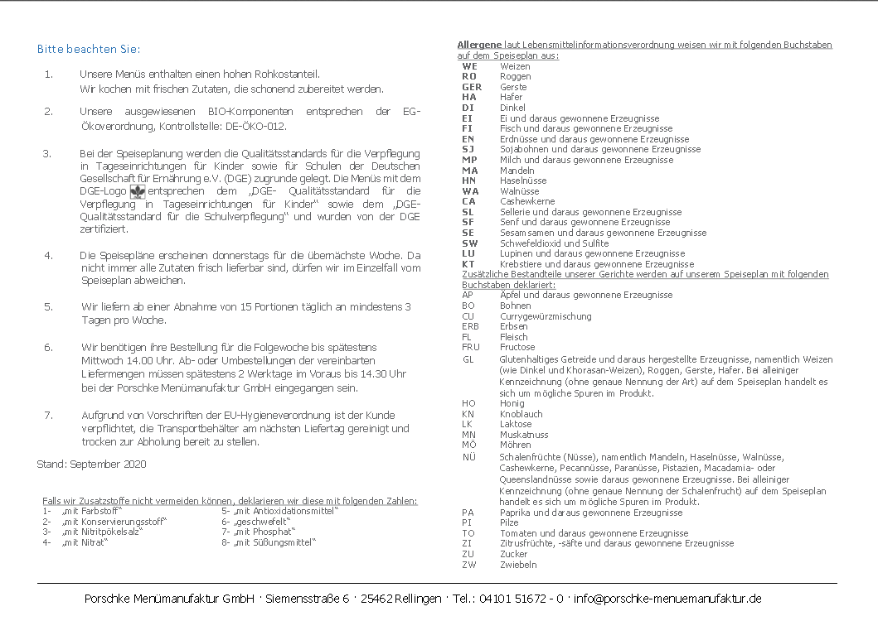

**Speiseplan-Spezial – KW 22 / 29.05. – 02.06.2023**

**Mittwoch, 24.05.2023**