|  |  |  |  |  |  |  |  |  |  |  |  |  |  |  |
| --- | --- | --- | --- | --- | --- | --- | --- | --- | --- | --- | --- | --- | --- | --- |
| **Montag** | | | **Dienstag** | | | **Mittwoch** | | | **Donnerstag** | | | **Freitag** | | |
|  | 95621 | **Knabberpaprika** (PA) |  | 95611 | **Knabberkohlrabi** |  | 95601 | **Knabbergurke** |  | 95591 | **Knabbermöhre** (MÖ) |  | 95601 | **Knabbergurke** |
|  | 94611 | **Blumenkohl in Soße** |  | 95791 | **Tomatensoße** (TO) |  | 95761 | **Brokkoli-Cremesoße lktfr. (MP**,KN,ZW) |  | 93281 | **Salzkartoffeln** |  | 93071 | **Paprika- Pizza mit Käse** (**MP**,PA,TO,ZU) |
|  | 94021 | **Reisbratling** |  | 93991 | **Maisherzi** |  | 93231 | **Glfr. Spirelli** (ERB)(ERB=Erbsenprotein) |  | 95851 | **Kräutersoße** (milchfrei) |  | 93081 | **Champignon-Zucchini-Pizza** (1,2,PI,ZU) |
|  | 94491 | **Spinat** |  | 95811 | **Pilzsoße** (PI) |  | 93591 | **Glf.Bolognese Gratin** (2,1,ERB,FL,TO,ZI) |  | 93401 | **Kartoffeln in Soße** (**SJ,**5, FRU,ZU,ZW) |  | 93091 | **Paprika-Pizza** (PA,TO,ZU) |
|  | 97001 | **Feta-Käse, gebacken** (**MP**) |  | 96231 | **Paprika-Kartoffeltopf** (PA) |  | 94181 | **Rinderhackfleisch** (FL) |  | 93961 | **Spinatbratling** |  | 96211 | **Gemüsecremesuppe ohne MÖ** |
|  | 94441 | **Laktfr. Rahmspinat** (**MP,**ZW) |  | 93501 | **Glfr. Knäckebrot** (**SJ**,ZU) |  | 95791 | **Tomatensoße** (TO) |  | 94161 | **Gebr. Hähnchenbrust** (FL) |  | 93551 | **Kaiserbrötchen** (AP,**LU,SJ**) |
|  | 95361 | **Weintrauben** (FRU) |  | 96631 | **Reiswaffel** |  | 95091 | **Bananendessert** (FRU**,SJ,**ZU) |  | 93551 | **Laugenbrötchen** (ERB**,SJ**,ZU) |  | 95211 | **Naturjoghurt** (**MP**) (fructosefrei) |
|  | 95311 | **Bananen** (FRU) |  | 94991 | **Glf. Doppelkeks** (**EI**,LK,**LU,MP,SJ,**ZU) |  | 96451 | **Lakt.fr. Quarkspeise** (**MP**) (fructosearm) |  | 95361 | **Weintrauben** (FRU) |  | 94901 | **Reis-Kokos-Keks** (fruktosefrei) |
|  | 94851 | **Schoko-Brezeln** (fruktosefreier Keks) |  | 95341 | **Honigmelone** (FRU) |  |  |  |  | 95311 | **Bananen** (FRU) |  |  |  |
|  |  |  |  |  |  |  |  |  |  | 94981 | **Herzkekse** (fructosefrei) |  |  |  |
|  |  |  |  |  |  |  |  |  |  |  |  |  |  |  |
|  |  |  |  |  |  |  |  | Veg. Alternative |  |  |  |  |  |  |
|  |  |  |  |  |  |  | 93191 | **Vollkornspirelli** (**WE**,GL) |  |  | Veg. Alternative |  |  |  |
|  |  |  |  |  |  |  | 95741 | **Brokkolisoße** (**WE**,**MP**, GL,KN,LK,MN,ZW) |  | 96411 | **Gemüsefrikadelle** (**HA**,**MP**,ERB,GL,LK,MN, MÖ,ZW) |  |  |  |



**Name des Kindes**

**Kürzel**

**Speiseplan-Spezial – KW 29 / 18.07. – 22.07.2022**

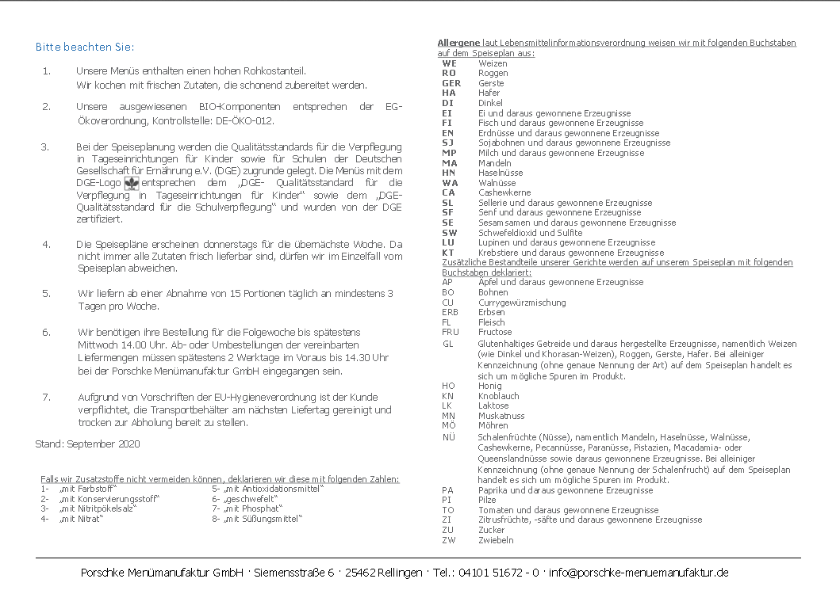

Mittwoch,24.11.2021