

**Mittwoch, den 04.09.19**

**Name des Kindes**

**Kürzel**

|  |  |  |  |  |  |  |  |  |  |  |  |  |  |  |
| --- | --- | --- | --- | --- | --- | --- | --- | --- | --- | --- | --- | --- | --- | --- |
| **Montag** | | | **Dienstag** | | | **Mittwoch** | | | **Donnerstag** | | | **Freitag** | | |
|  | 95621 | **Knabberpaprika** (PA) |  | 95591 | **Knabbermöhre** (MÖ) |  | 93371 | **Kartoffelbrei** (milchfrei) |  | 95611 | **Knabberkohlrabi** |  | 95601 | **Knabbergurke** |
|  | 96141 | **Kürbis-Kartoffelsuppe** (MÖ) |  | 95881 | **Gemüsebolognese** (TO) |  | 94431 | **Blumenkohl in Soße Lktfr.** (MP,ZW) |  | 93131 | **Parboiled Reis** |  | 93371 | **Kartoffelbrei laktosefrei** (MP) |
|  | 93551 | **Kaisersemmel** (AP,LU,SJ) |  | 93231 | **Glfr. Spirelli** (ERB)(ERB=Erbsenprotein) |  | 94001 | **Hirsebratling** (MÖ) |  | 95821 | **Möhren-Zucchini-Soße** (MÖ) |  | 93281 | **Salzkartoffeln** |
|  | 95871 | **veg. Currysoße** (FRU,CU,KN,PA,ZW,ZI,ZU) |  | 94181 | **Rinderhackfleisch** (FL) |  | 93841 | **Kräutermargarine** |  | 93231 | **Glfr. Bandnudeln** (ERB) |  | 95871 | **Kürbissoße** |
|  | 94161 | **Gebratene Hähnchen-bruststreifen** (FL) |  | 95761 | **Gorgonzolasoße Laktfr.** (MP,ZW) |  | 94471 | **Kohlrabi, pur** |  | 95961 | **Grünes-Pesto** (KN,2,1) |  | 93991 | **Maisherzi** |
|  | 95931 | **Geflügelcurry laktfr.** (CU,FL,KN,MP) |  | 94871 | **Maiswaffel** |  | 94161 | **gebr. Hähnchenbrust** (FL) |  | 93551 | **Mehrkornbrötchen** (AP,LU,SJ,ZU) |  | 93121 | **Seelachs mit Topping** (FI,SJ,ZI,ZW) |
|  | 95211 | **Naturjoghurt** (MP) |  |  |  |  | 95361 | **Weintrauben** |  | 94991 | **Buttergebäck** (MP,ZU) |  | 94131 | **Gebratenes Seelachsfilet** (FI) |
|  | 93791 | **Mais-Flakes** |  |  |  |  | 95311 | **Banane** |  | 94981 | **Herzkekse** (fructosefrei) |  | 95341 | **Honigmelone** |
|  | 95091 | **Vanilledessert** (SJ,ZU,ZI) |  |  |  |  | 94941 | **Reiszwerg** (fructosefreier Keks) |  |  |  |  | 95311 | **Banane** |
|  |  |  |  |  |  |  |  |  |  |  |  |  | 94951 | **Schoko-Herzkekse**  (fructosearme Kekse) |
|  |  |  |  |  |  |  |  |  |  |  |  |  |  |  |
|  |  | Veg. Alternative: |  |  | Veg. Alternative: |  |  | Veg. Alternative: |  |  |  |  |  | Veg. Alternative: |
|  | 95751 | **Fruchtiges curry mit Paneer**(CU,FRU,GL,KN,LK,MN,MP,PA,WE,ZI,ZU,ZW) |  | 95741 | **Möhrensoße** (CU,KN,LK,MÖ,MP,ZW) |  | 94101 | **Sonnenblumenkern-Frikadelle** (GL,HA,LK,MN,MP,ZW) |  |  |  |  | 94081 | **Veg. Bällchen** (EI,GER, GL,SF,SJ,SL,WE,ZU,ZW) |

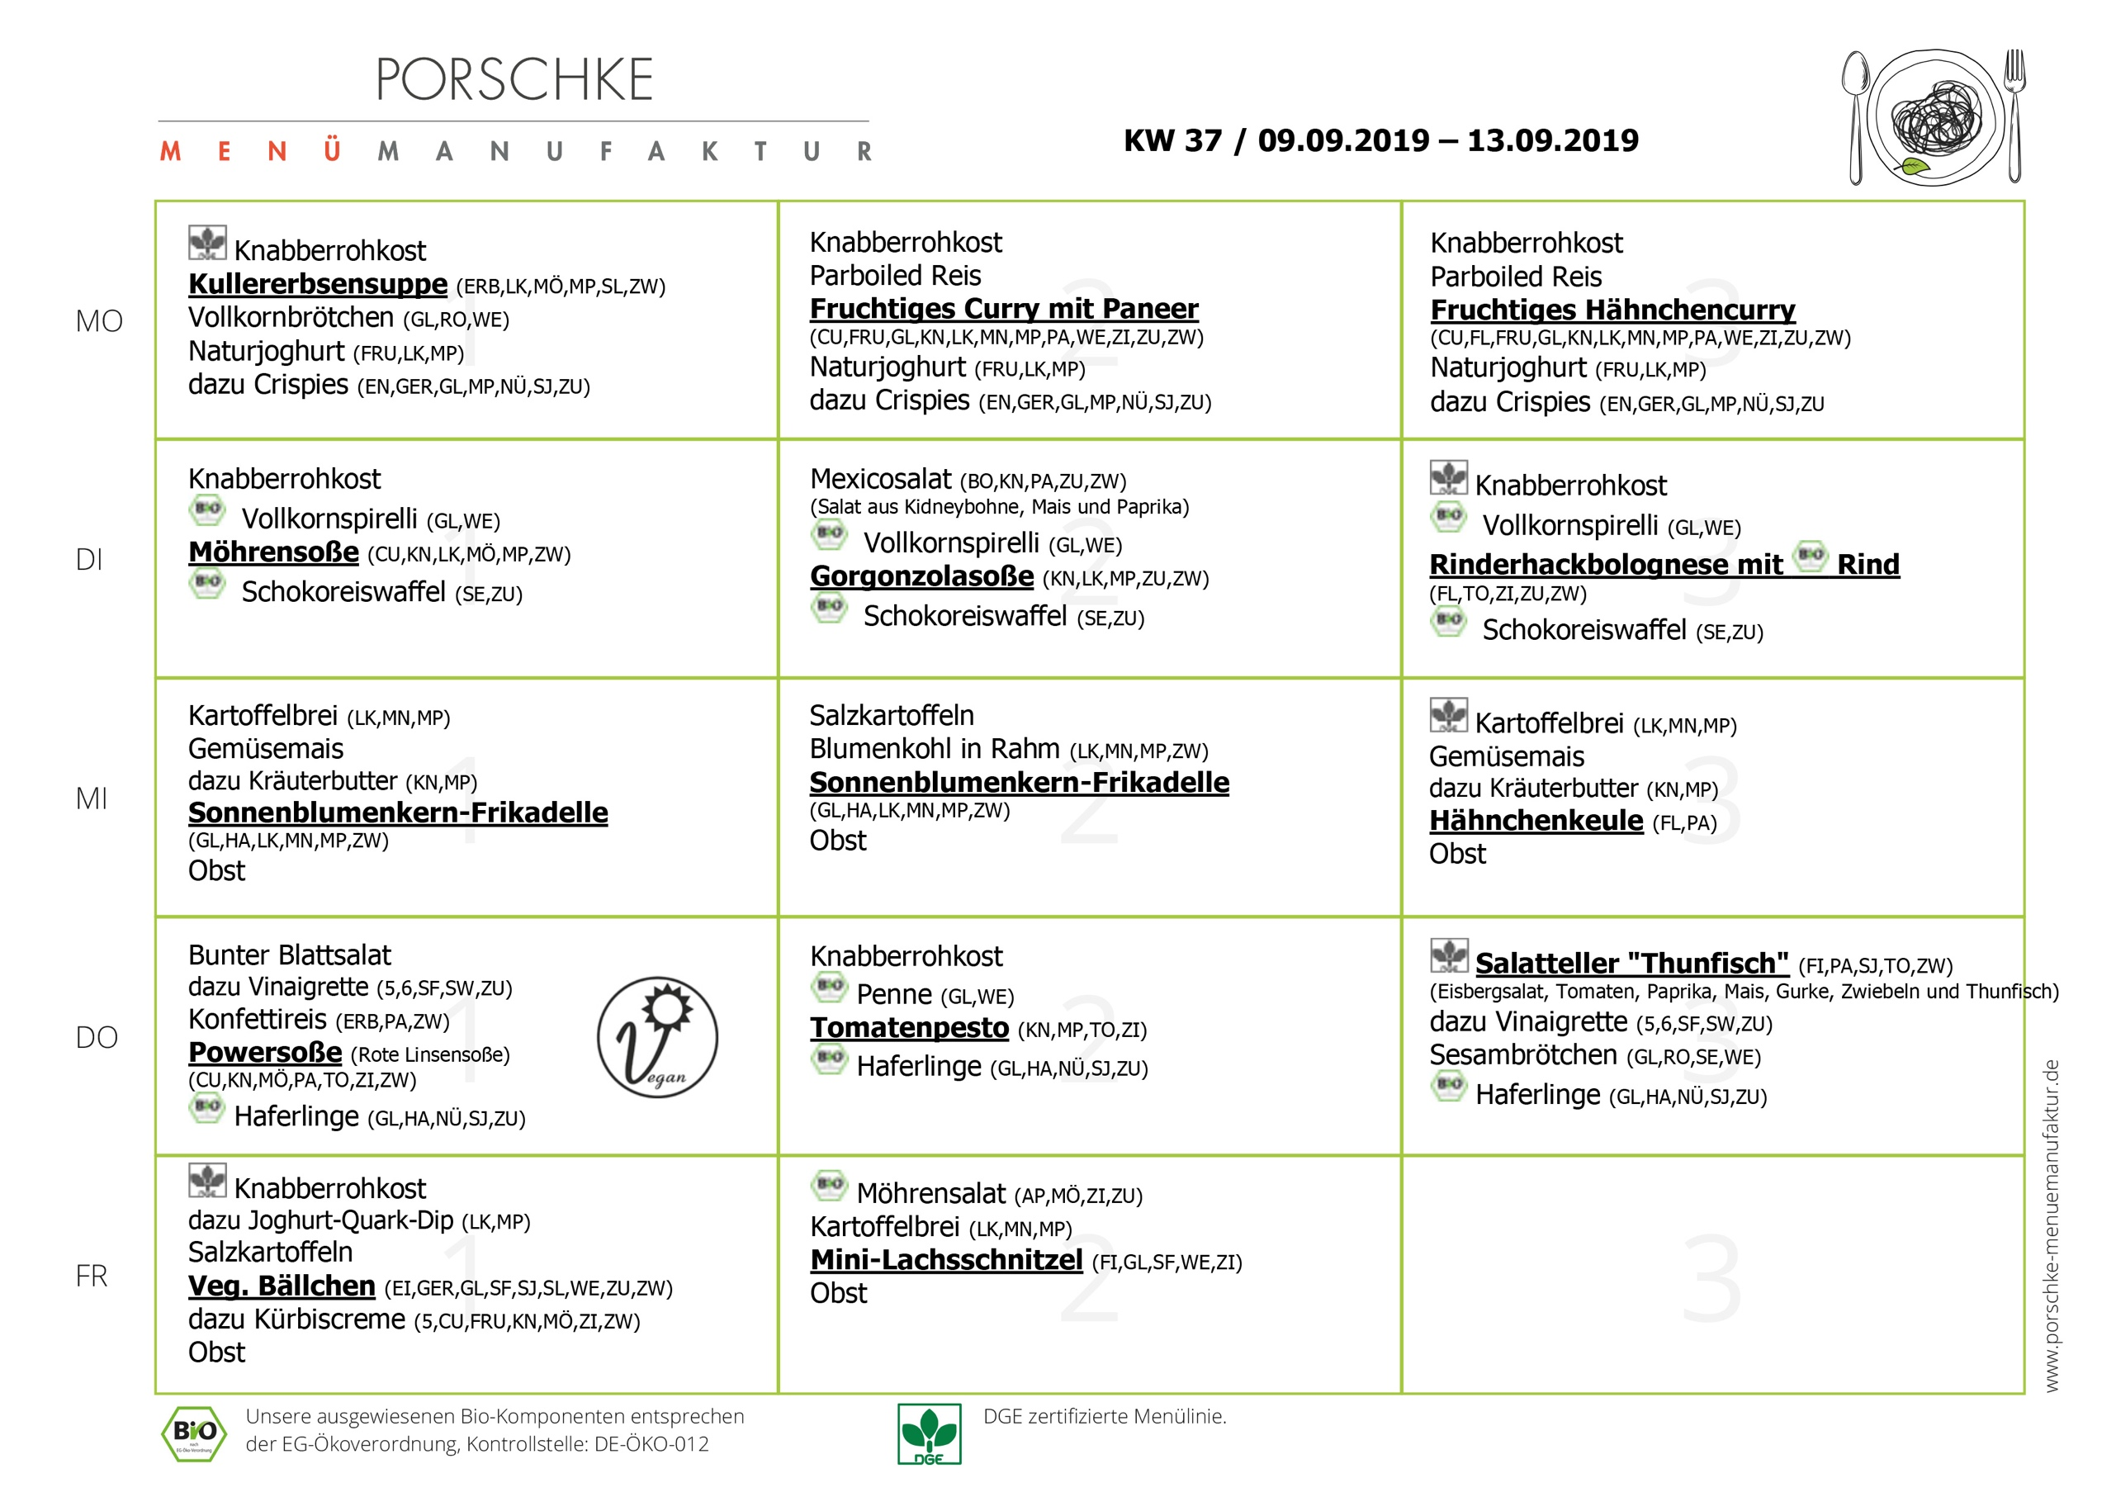

**Speiseplan-Spezial – KW 37/ 09.09. – 13.09.2019**