

**Name des Kindes**

**Speiseplan-Spezial – KW 44 / 30.10. – 03.11.2017**

**Kürzel**

|  |  |  |  |  |  |  |  |  |  |  |  |  |  |  |
| --- | --- | --- | --- | --- | --- | --- | --- | --- | --- | --- | --- | --- | --- | --- |
| **Montag** | | | **Dienstag** | | | **Mittwoch** | | | **Donnerstag** | | | **Freitag** | | |
|  | 95621 | **Knabberpaprika** (PA) |  |  |  |  | 95591 | **Knabbermöhre** (MÖ) |  | 95601 | **Knabbergurke** |  | 95611 | **Knabberkohlrabi** |
|  | 96131 | **Kartoffelsuppe** (MÖ) |  |  |  |  | 93231 | **Glutenfreie Spirelli** (ERB) |  | 93401 | **Kartoffeln in Soße** (5,SJ,FRU,ZU,ZW) |  | 93591 | **Überbackene**  **Käsenudeln Laktfr.** (ERB,MP,SF,ZW) |
|  | 93551 | **Mehrkornbrötchen** (AP,LU,SJ,ZU) |  |  |  |  | 95761 | **Käsesoße Laktosefrei** (MP) |  | 93281 | **Salzkartoffeln** |  | 93051 | **Nudelauflauf** (ERB,MÖ) **(ERB=Erbsenprotein)** |
|  | 93991 | **Maisherzi**  **Reformationstag** |  |  |  |  | 95811 | **Pilzsoße** (PI) |  | 95851 | **Kräutersoße** |  | 95671 | **Tomatenketchup** (TO) |
|  | 95681 | **Soja-Tsatsiki** (5**,**KN,SJ) |  |  |  |  | 95931 | **Hähnchenbrust in Thymiansoße** (FL,MP,TO,ZU,ZW) |  | 93971 | **Fischstäbchen** (FI,ZW) |  | 93131 | **Parboiled Reis** |
|  | 94181 | **Rinderhackfleisch** (FL) |  |  |  |  | 94161 | **Gebr. Hähnchenbrust-streifen** (FL) |  | 93961 | **Spinatbratling** |  | 96271 | **Rote-Bete-Möhrenpfanne** (5,FRU,KN,MÖ,SJ,ZU,ZW) |
|  | 95311 | **Banane** |  |  |  |  | 95001 | **Vanille-Cookie** (EI,ZI,ZU) |  | 94131 | **Gebratenes Seelachsfilet** (FI) |  | 94161 | **Gebr. Hähnchenbrust-streifen** (FL) |
|  | 95341 | **Honigmelone** |  |  |  |  | 95091 | **Süße Reisspeise** |  | 93501 | **Glutenfreies Knäckebrot** (SJ,ZU) |  | 93551 | **Kaisersemmel** (AP,LU,SJ) |
|  | 94941 | **Reiszwerg** (fructosefreier Keks) |  |  |  |  |  |  |  | 96161 | **Kürbis-Kartoffelsuppe** (MÖ) |  | 95171 | **Aprikosenkompott** (ZI) |
|  |  |  |  |  |  |  |  |  |  | 95361 | **Weintrauben** |  | 94981 | **Herzkekse** (fructosefrei) |
|  |  |  |  |  |  |  |  |  |  | 95311 | **Banane** |  |  |  |
|  |  |  |  |  |  |  |  |  |  | 94951 | **Schoko-Herzkekse**  (fructosearme Kekse) |  |  |  |
|  |  | Veg. Alternative: |  |  |  |  |  | Veg. Alternative: |  |  |  |  |  |  |
|  | 94081 | **Falafelbällchen** (ERB,GL,WE,ZW) |  |  |  |  | 95751 | **Napoli Soße** (FRU,KN,TO,ZI,ZW) |  |  |  |  |  |  |

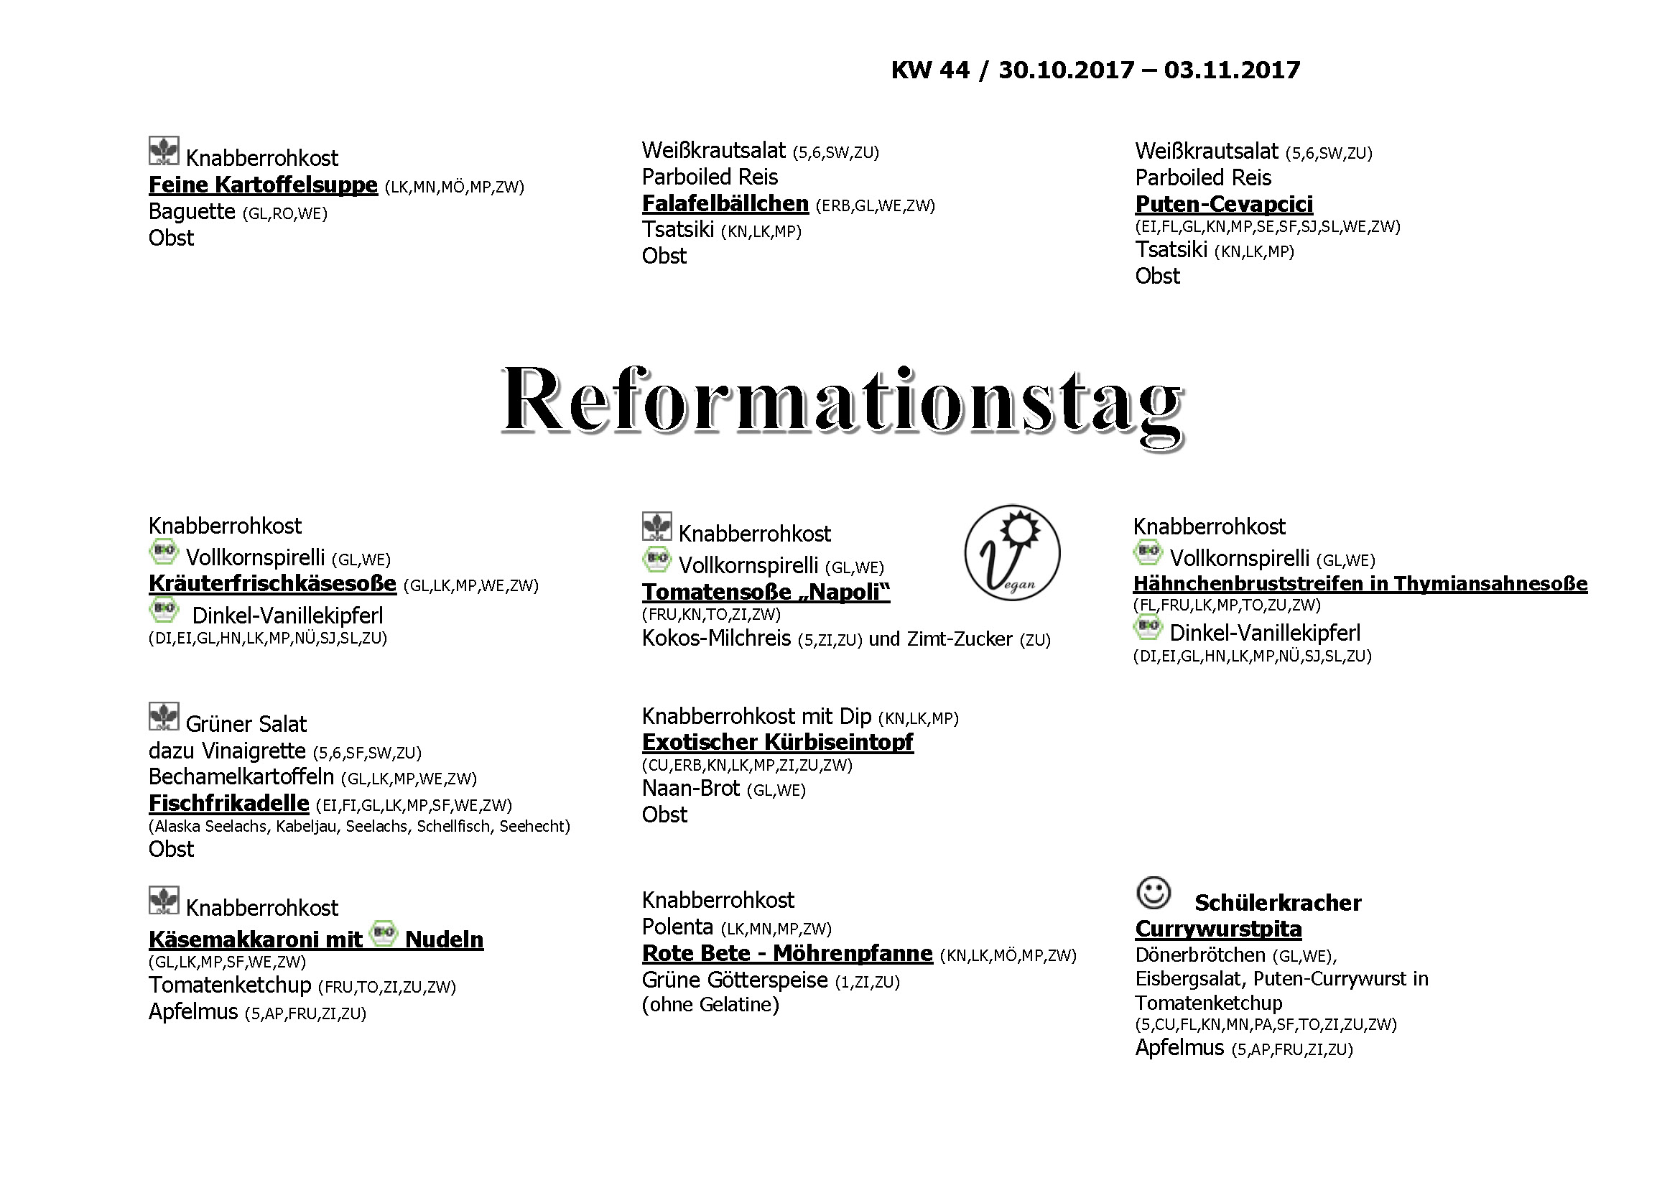

**Mittwoch, den 25.10.2017**