

**Name des Kindes**

**Kürzel**

|  |  |  |  |  |  |  |  |  |  |  |  |  |  |  |
| --- | --- | --- | --- | --- | --- | --- | --- | --- | --- | --- | --- | --- | --- | --- |
| **Montag** | | | **Dienstag** | | | **Mittwoch** | | | **Donnerstag** | | | **Freitag** | | |
|  | 93371 | **Laktfr.-Kartoffelbrei** (MP) |  | 95611 | **Knabberkohlrabi** |  | 95591 | **Knabbermöhre** (MÖ) |  | 95601 | **Knabbergurke** |  | 95621 | **Knabberpaprika** (PA) |
|  | 93281 | **Kartoffeln** |  | 95761 | **Currysoße Lktfr.** (MP,CU,TO,KN,ZW,ZU,ZI) |  | 93371 | **Reismilch-Kartoffelbrei** |  | 93231 | **Bandnudeln** (ERB) |  | 93591 | **Laktfr. Kartoffelgratin** (MN,MP,ZW) |
|  | 94471 | **Kohlrabi in Rahm** (5,FRU,SJ,ZU) |  | 93121 | **Glfr. Nudel-Lachs-Auflauf** (ERB,FI,MÖ) |  | 94421 | **Laktfr. Rahmspinat** (MP,ZW) |  | 95791 | **Tomatensoße** (TO) |  | 93061 | **Gemüse-Kartoffelauflauf** (MÖ) |
|  | 94541 | **Sauerkraut** |  | 93991 | **Maisherzi** |  | 94491 | **Spinat** |  | 95811 | **Champignon-Sahnesoße Laktfr.** (MP,PI,ZW) |  | 93961 | **Spinatbratling** |
|  | 94011 | **Currybratling** (CU,KN,MÖ) |  | 95891 | **Rahmsoße** (5,FRU,SJ,TO,ZU,ZW) |  | 94011 | **Reisbratling** |  | 93551 | **Laugenbrötchen** (ERB,SJ,ZU) |  | 95681 | **Soja-Tsatsiki** (5**,**KN,SJ,ZU) |
|  | 95341 | **Honigmelone** |  | 95011 | **Schokowaffeln** (ZU,SJ) |  | 93111 | **Glfr. Pizza mit Rinderhack** (FL,PA,TO,ZI,ZU) |  | 95521 | **Reismilch-Kräuter-dressing** |  | 95341 | **Honigmelone** |
|  | 95311 | **Banane** |  | 94901 | **Reis-Kokos-Keks** (fructosefrei) |  | 96141 | **Tomatensuppe**  (TO,SJ,FRU,5,ZU) |  | 95231 | **Reismilch-Schokopudding** |  | 95311 | **Banane** |
|  | 94981 | **Herzkekse**  (fructosearme Kekse) |  |  |  |  | 93571 | **Glfr. Croutons** |  | 96451 | **Laktfr. Pudding** (1,MP,ZU) |  | 94951 | **Schoko-Herzkekse (fructosefrei)** |
|  |  |  |  |  |  |  | 95361 | **Weintrauben** |  | 95211 | **Laktfr. Naturjoghurt** (MP) |  |  |  |
|  |  |  |  |  |  |  | 95311 | **Banane** |  |  |  |  |  |  |
|  |  |  |  |  |  |  | 94871 | **Maiswaffel** |  |  |  |  |  |  |
|  |  |  |  |  |  |  |  |  |  |  |  |  |  |  |
|  |  | Veg. Alternative: |  |  |  |  |  |  |  |  |  |  |  |  |
|  | 94301 | **Veg. Bratwurst** (1,EI,ERB,GL,KN,MN,SJ,WE,ZI,ZU,ZW) |  |  |  |  |  |  |  |  |  |  |  |  |

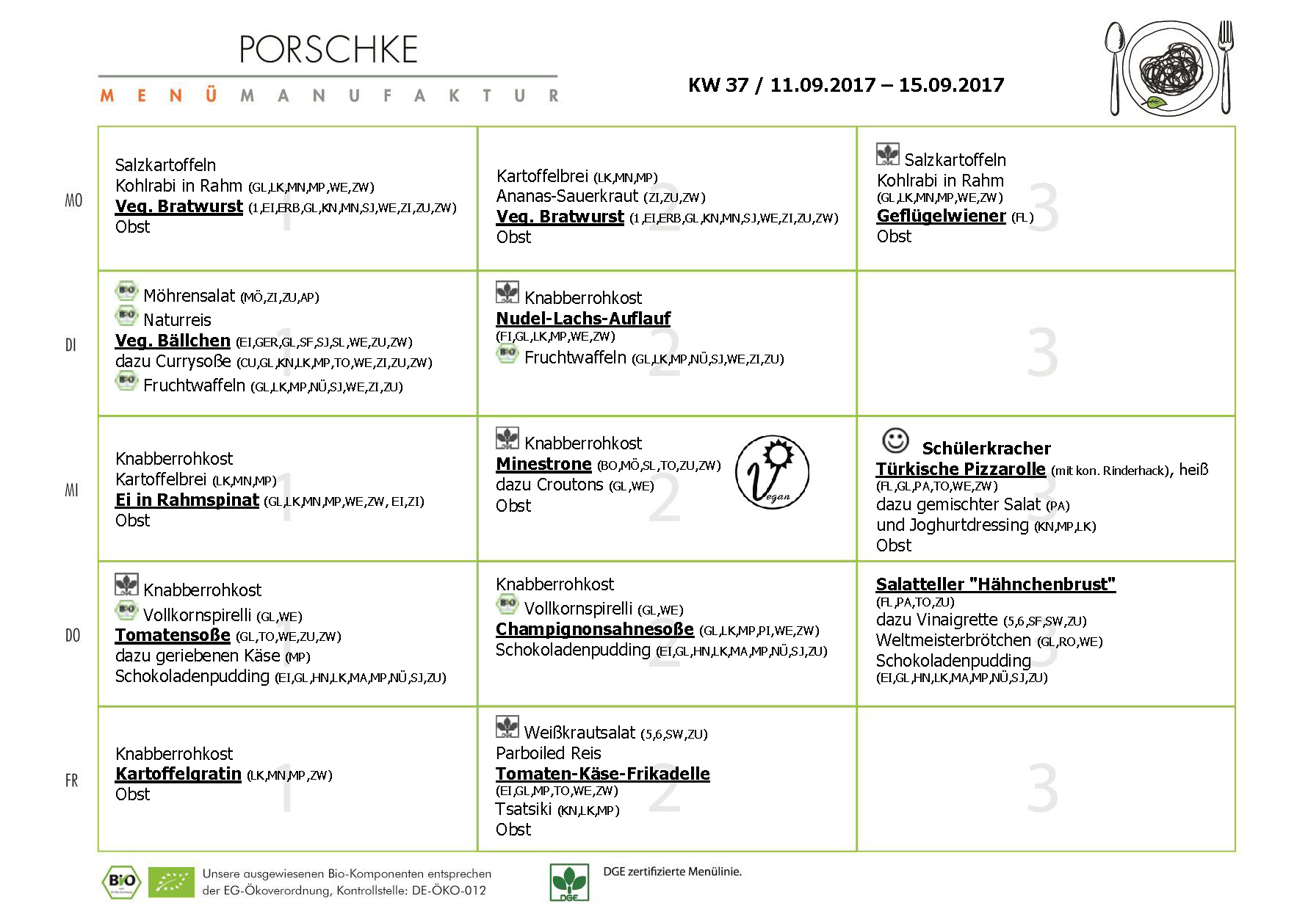

**Mittwoch, den 06.09.2017**

**Speiseplan-Spezial – KW 37 / 11.09.-15.09.17**