

**Name des Kindes**

**Speiseplan-Spezial – KW 35/ 28.08. – 01.09.2017**

**Kürzel**

|  |  |  |  |  |  |  |  |  |  |  |  |  |  |  |
| --- | --- | --- | --- | --- | --- | --- | --- | --- | --- | --- | --- | --- | --- | --- |
| **Montag** | | | **Dienstag** | | | **Mittwoch** | | | **Donnerstag** | | | **Freitag** | | |
|  | 95601 | **Knabbergurke** |  | 95621 | **Knabberpaprika** (PA) |  | 93371 | **Laktosefreier Kartoffelbrei** (MP) |  | 95611 | **Knabberkohlrabi** |  | 95591 | **Knabbermöhre** (MÖ) |
|  | 94011 | **Currybratling** (CU,KN,MÖ) |  | 93131 | **Parboiled Reis** |  | 93281 | **Kartoffeln** |  | 93231 | **Glfr. Spirelli** (ERB)(ERB=Erbsenprotein) |  | 96171 | **Blumenkohlsuppe** |
|  | 95881 | **Lktfr. Gemüserahm** (MÖ,MP) |  | 95791 | **Tomatensoße** (TO) |  | 94441 | **Gemüsemais** |  | 95791 | **Gemüsebolognese** (TO) |  | 93501 | **Glfr. Knäckebrot** (SJ,ZU) |
|  | 94161 | **Gebratene Hähnchen-bruststreifen** (FL) |  | 96381 | **Lachsquiche Lktfr.** (1,Ei,SJ,FI,MN,MP,ZI,ZU) |  | 94011 | **Reisbratling** |  | 94181 | **Rinderhackfleisch** (FL) |  | 94581 | **Gemüsecürry** (5,CU,FRU,KN,MÖ,SJ,ZI,ZU, ZW) |
|  | 95901 | **Zucchini in Soße** |  | 94131 | **Gebratenes Seelachsfilet** (FI) |  | 93841 | **Kräutermargarine** |  | 95761 | **Gorgonzolasoße Laktfr.** (MP,ZW) |  | 94601 | **Möhren-Currysoße** (CU,ERB,KN,MÖ) |
|  | 95091 | **Fruchtbällchen** (AP,FRU,NÜ) |  | 93551 | **Laugenbrötchen** (ERB,SJ,ZU) |  | 95311 | **Banane** |  | 95931 | **Rinderhackbolognese** (FL,TO,ZI) |  | 94691 | **Pfannkuchen Laktosefrei** (EI,MP) |
|  | 94901 | **Reis-Kokos-Keks** **(fructosefrei)** |  | 95091 | **Soja-Stracciatella Joghurt** (5,SJ,FRU,ZU) |  | 95341 | **Honigmelone** |  | 94991 | **Buttergebäck** (MP,ZU) |  | 94681 | **Eifr. Pfannkuchen** |
|  |  |  |  | 95211 | **Laktfr. Naturjoghurt** (MP) |  | 94851 | **Schoko-Brezeln** (fructosefreie Kekse) |  | 94871 | **Maiswaffel** |  | 93821 | **Traubenzucker** |
|  |  |  |  | 94981 | **Herzkekse (fructosefrei)** |  |  |  |  |  |  |  | 95171 | **Pflaumenkompott, kalt** |
|  |  |  |  |  |  |  |  |  |  |  |  |  | 95361 | **Weintrauben** |
|  |  |  |  |  |  |  |  |  |  |  |  |  | 95311 | **Banane** |
|  |  | Veg. Alternative: |  |  |  |  |  | Veg. Alternative: |  |  | Veg. Alternative: |  | 94941 | **Reiszwerg** (fruktosefrei) |
|  | 94081 | **Veg. Bällchen** (EI,GER,GL,SF,SJ,SL,WE,ZU, ZW) |  |  |  |  | 94101 | **Sonnenblumenkern-Frikadelle** (GL,HA,LK,MN,MP,ZW) |  | 95741 | **Veg. Bolognese** (GL,SJ,TO,WE,ZI,ZU,ZW) |  |  |  |

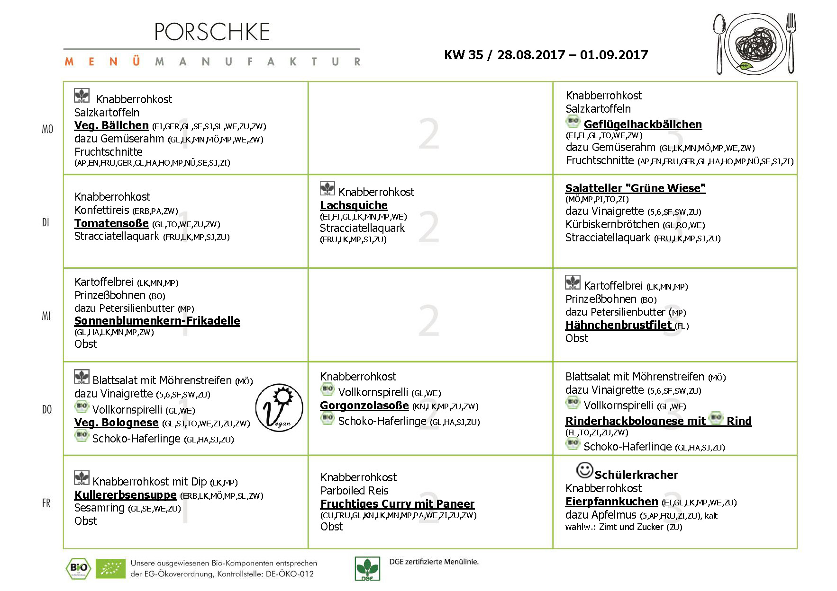

**Mittwoch, den 23.08.2017**