

**Name des Kindes**

**Kürzel**

|  |  |  |  |  |  |  |  |  |  |  |  |  |  |  |
| --- | --- | --- | --- | --- | --- | --- | --- | --- | --- | --- | --- | --- | --- | --- |
| **Montag** | | | **Dienstag** | | | **Mittwoch** | | | **Donnerstag** | | | **Freitag** | | |
|  | 95621 | **Knabberpaprika** (PA) |  | 95601 | **Knabbergurke** |  | 95611 | **Knabberkohlrabi** |  | 95591 | **Knabbermöhre** (MÖ) |  | 95601 | **Knabbergurke** |
|  | 94511 | **Bohnen, pur** (BO) |  | 93231 | **Glfr. Teff Nudeln** |  | 93121 | **Kartoffel-Fisch-Auflauf Lktfr.** (FI,MÖ,MP,ZI,ZW) |  | 93281 | **Salzkartoffeln** |  | 94691 | **Pfannkuchen Laktosefrei** (EI,MP) |
|  | 94611 | **Zucchini in Soße** |  | 95821 | **Möhrensoße** (5,MÖ,FRU,SJ,ZU) |  | 93991 | **Maisherzi** |  | 95981 | **Paprikapfanne mit Rind** (PA,FL) |  | 94681 | **Eifreie Pfannkuchen** |
|  | 94161 | **Gebratene Hähnchenbrust** (FL) |  | 95931 | **Geflügelcarbonara Lktfr.** (FRU,FL,MP,TO,ZU) |  | 93551 | **Kaisersemmel** (AP,LU,SJ) |  | 94181 | **Rindfleischstreifen** (FL) |  | 93821 | **Traubenzucker** |
|  | 94011 | **Currybratling** (CU,KN,MÖ) |  | 95211 | **Naturjoghurt** (MP) |  | 94131 | **Gebr. Seelachsfilet pur** (FI) |  | 95881 | **Gemüsebolognese** (TO) |  | 95171 | **Heidelbeerkompott** |
|  | 95341 | **Honigmelone** |  | 93791 | **Mais-Flakes** |  | 95661 | **Paprika-Zucchini-Dip** (PA) |  | 96191 | **Brokkolicremesuppe** (5,FRU,ZU,SJ) |  | 94001 | **Hirsebratling** (MÖ) |
|  | 95311 | **Banane** |  | 95091 | **Vanillejoghurt** (SJ) |  | 93281 | **Salzkartoffeln** |  | 93501 | **Glfr. Knäckebrot** (SJ,ZU) |  | 95851 | **Reismilch-Kräutersoße** |
|  | 95021 | **Schoko-Brezeln** (fructosefreie Kekse) |  |  |  |  | 94831 | **Sesam-Krokant-Riegel** (EN,FRU,HN,HO,MA,SE,WA, NÜ) |  | 95231 | **Reismilch-Schokopudding** |  | 95341 | **Honigmelone** |
|  |  |  |  |  |  |  | 95361 | **Weintrauben** |  | 96451 | **Laktfr. Pudding** (1,MP,ZU) |  | 95311 | **Banane** |
|  |  |  |  |  |  |  | 95311 | **Banane** |  | 94981 | **Herzkekse** (fructosefrei) |  | 94941 | **Reiszwerg (fructosefreier Keks)** |
|  |  |  |  |  |  |  | 94871 | **Maiswaffel** |  |  |  |  |  |  |
|  |  |  |  |  |  |  |  |  |  |  |  |  |  |  |
|  |  | Veg. Alternative: |  |  | Veg. Alternative: |  |  |  |  |  | Veg. Alternative: |  |  |  |
|  | 94301 | **Veg. Bratwurst**  (1,EI,ERB,GL,KN,MN,SJ,WE, ZI,ZU,ZW) |  | 95751 | **Möhrensoße** (CU,LK,MÖ,MP,KN,ZW) |  |  |  |  | 96001 | **Brokkolicremesuppe** (GL,LK,MN,MP,MÖ,SL,WE, ZW) |  |  |  |

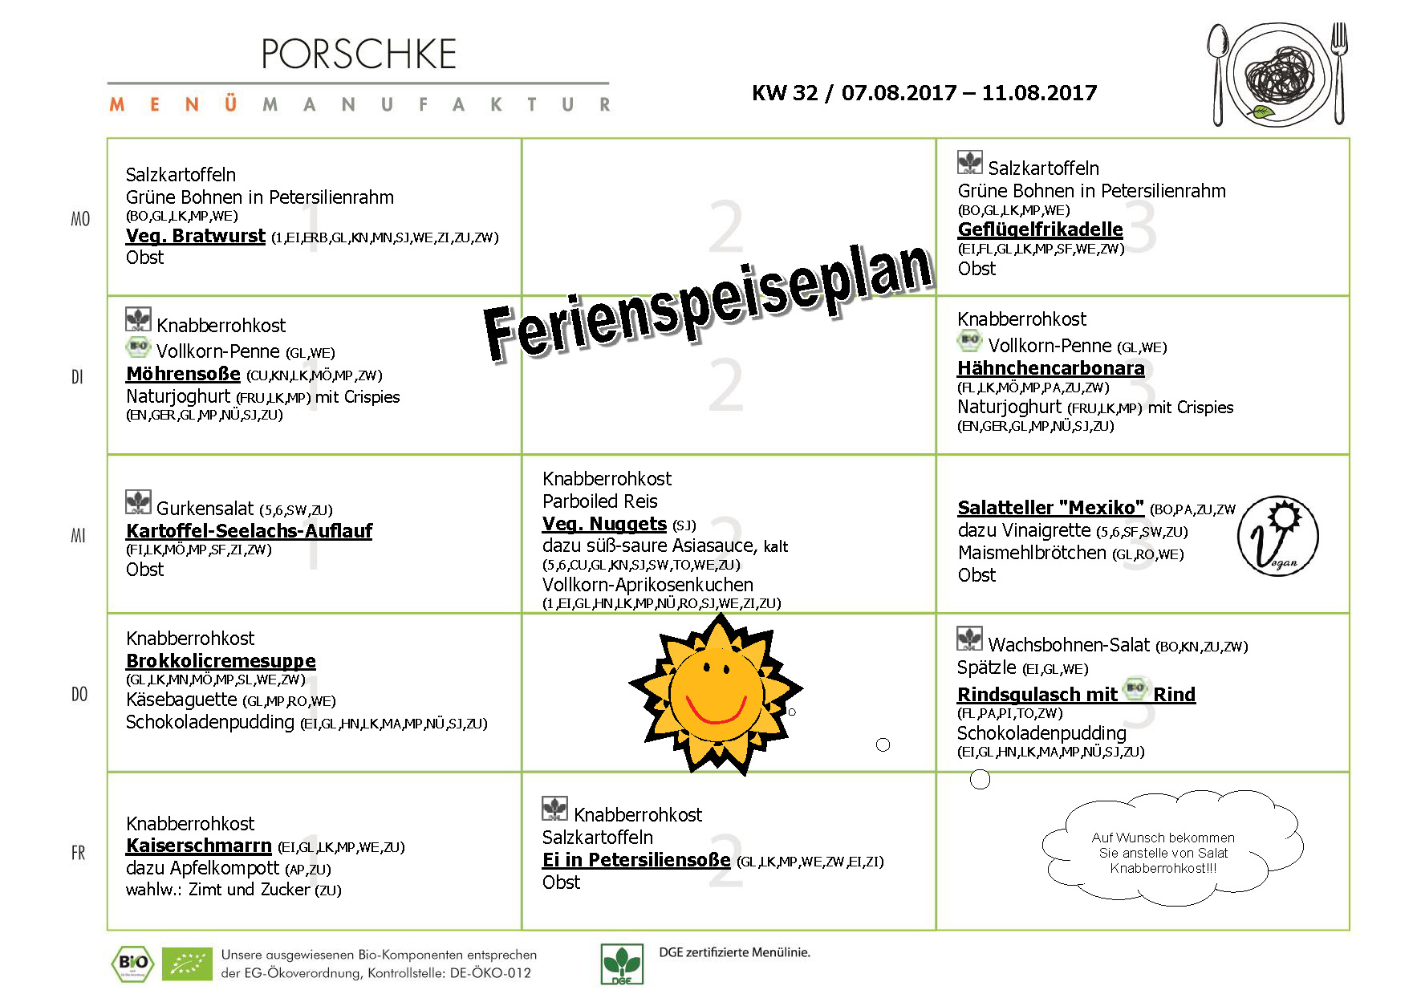

**Mittwoch, den 02.08.2017**

**Speiseplan-Spezial – KW 32 / 07.08. – 11.08.2017**