

**Name des Kindes**

**Kürzel**

|  |  |  |  |  |  |  |  |  |  |  |  |  |  |  |
| --- | --- | --- | --- | --- | --- | --- | --- | --- | --- | --- | --- | --- | --- | --- |
| **Montag** | | | **Dienstag** | | | **Mittwoch** | | | **Donnerstag** | | | **Freitag** | | |
|  | 93371 | **Laktfr. Kartoffelbrei** (MP) |  | 95611 | **Knabberkohlrabi** |  | 95591 | **Knabbermöhre** (MÖ) |  | 95601 | **Knabbergurke** |  | 95621 | **Knabberpaprika** (PA) |
|  | 93281 | **Kartoffeln** |  | 96261 | **Linsensuppe** (CU,KN,MÖ) |  | 93231 | **Bandnudeln** (ERB) |  | 94421 | **Laktfr. Rahmspinat** (MP,ZW) |  | 93591 | **Laktfr. Kartoffelgratin** (MN,MP,ZW) |
|  | 94471 | **Kohlrabi in Rahm** (5,FRU,SJ,ZU) |  | 93551 | **Kaisersemmel** (AP,LU,SJ) |  | 95791 | **Tomatensoße** (TO) |  | 94491 | **Spinat** |  | 93061 | **Gemüse-Kartoffelauflauf** (MÖ) |
|  | 94431 | **Blumenkohl pur** |  | 93991 | **Maisherzi** |  | 95811 | **Champignon-Sahnesoße laktosefrei** (MP,PI,ZW) |  | 93961 | **Spinatbratling** |  | 93231 | **Glutenfr. Spirelli** (ERB)(ERB=Erbsenprotein) |
|  | 93711 | **Kräutermargarine** |  | 95891 | **Rahmsoße** (5,FRU,SJ,TO,ZU,ZW) |  | 93551 | **Laugenbrötchen** (ERB,SJ,ZU) |  | 94161 | **Gebratene Hähnchenbrust** (FL) |  | 94331 | **Thunfischsoße** (FI,SJ,TO,ZI) |
|  | 94011 | **Currybratling** (CU,KN,MÖ) |  | 95671 | **Tomatenketchup** (TO) |  | 95021 | **Reis-Kokos-Keks** (fructosefrei) |  | 95661 | **Paprikadip** (PA) |  | 94131 | **Gebratenes Seelachsfilet** (FI) |
|  | 95341 | **Honigmelone** |  | 95151 | **Pfirsich-Reismilchshake** |  |  |  |  | 95361 | **Weintrauben** |  | 95831 | **Brokkolisoße** |
|  | 95311 | **Banane** |  | 95001 | **Mürbeteigtaler** (EI,SJ,ZI,ZU) |  |  |  |  | 95311 | **Banane** |  | 95211 | **Laktfr. Naturjoghurt** (MP) |
|  | 94981 | **Herzkekse**  (fructosearme Kekse) |  | 94951 | **Schoko-Herzkekse (fructosefrei)** |  |  |  |  | 96351 | **Schoko-Crossies** (SJ)  **(fructosearm)** |  | 95091 | **Erdbeer-Sojajoghurt** (SJ,5,FRU) |
|  |  |  |  |  |  |  |  |  |  |  |  |  |  |  |
|  |  |  |  |  |  |  |  |  |  |  |  |  |  |  |
|  |  |  |  |  |  |  |  |  |  |  |  |  |  |  |
|  |  | Veg. Alternative: |  |  | Veg. Alternative: |  |  |  |  |  | Veg. Alternative: |  |  |  |
|  | 94301 | **Veg. Bratwurst** (1,EI,ERB,GL,KN,MN,SJ,WE,ZI,ZU,ZW) |  | 94101 | **Gemüsebratling** (ZW,GL,HA,MP,CU) |  |  |  |  | 94101 | **Tomaten-Käse-Bratling** (EI,GL,MP,TO,WE,ZW) |  |  |  |

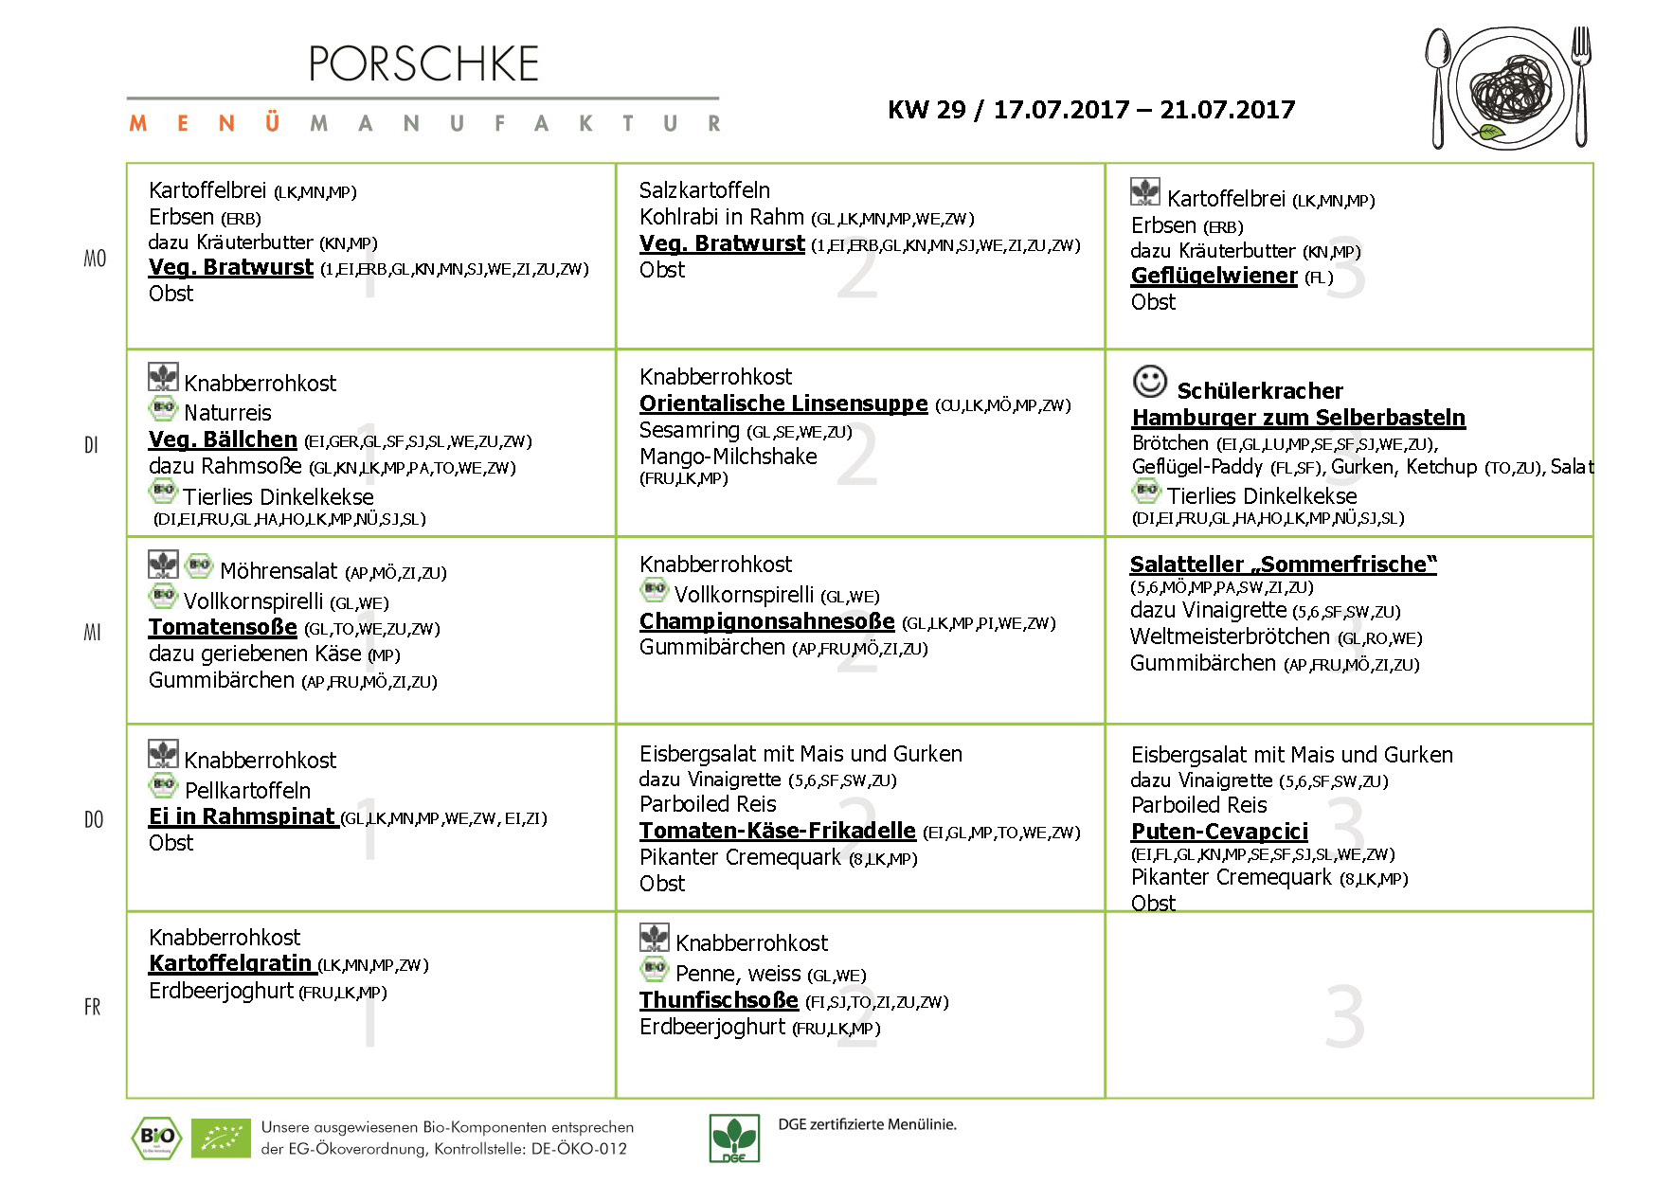

**Speiseplan-Spezial – KW 29 / 17.07.-21.07.17**

**Mittwoch, den 12.07.2017**