

**Mittwoch, den 31.05.2017**

**Name des Kindes**

**Kürzel**

|  |  |  |  |  |  |  |  |  |  |  |  |  |  |  |
| --- | --- | --- | --- | --- | --- | --- | --- | --- | --- | --- | --- | --- | --- | --- |
| **Montag** | | | **Dienstag** | | | **Mittwoch** | | | **Donnerstag** | | | **Freitag** | | |
|  |  |  |  | 95621 | **Knabberpaprika** (PA) |  | 95611 | **Knabberkohlrabi** |  | 95591 | **Knabbermöhre** (MÖ) |  | 95601 | **Knabbergurke** |
|  |  |  |  | 94431 | **Blumenkohl in Cremesoße** (2,1,5,FRU,SJ,ZU, ZW) |  | 95881 | **Laktfr. Gemüserahm** (MÖ,MP) |  | 93401 | **Rahmkartoffeln** (5,FRU,SJ,ZU,ZW) |  | 93231 | **Glfr. Spirelli** (ERB) **(ERB=Erbsenprotein)** |
|  |  |  |  | 94441 | **Laktfr. Rahmspinat** (MP,ZW) |  | 93991 | **Maisherzi** |  | 93281 | **Salzkartoffeln** |  | 95761 | **Laktfr. Käsesoße rosa** (MP,FRU,TO) |
| Pfingstmontag |  |  |  | 94491 | **Spinat** |  | 95891 | **Rahmsoße** (5,FRU,SJ,TO,ZU,ZW) |  | 94161 | **Putenfrikadelle** (FL,SF) |  | 95891 | **Vegane Cremesoße** (1,2,5,FRU,SJ,ZU) |
|  |  |  |  | 93551 | **Mehrkornbrötchen** (AP,LU,SJ,ZU) |  | 93201 | **Glfr. Spaghetti** (ERB) |  | 94021 | **Reisbratling** |  | 93071 | **Paprika- Pizza mit Käse** (MP,PA,TO,ZU) |
|  |  |  |  | 95791 | **Tomatensoße** (TO) |  | 95961 | **Grünes-Pesto** (KN,2,1) |  | 95831 | **Brokkolisoße** |  | 93081 | **Brokkoli-Mais-Pizza** (ZU) |
|  |  |  |  | 94161 | **Hähchenbruststreifen** (FL) |  | 95091 | **Soja-Stracciatella Joghurt** (5,SJ,FRU,ZU) |  | 96261 | **Tomatensuppe**  (TO,5,FRU,SJ,ZU,ZI) |  | 93091 | **Paprika-Pizza** (PA,TO,ZU) |
|  |  |  |  | 94291 | **Eier** (EI,ZI) |  | 95211 | **Laktfr. Naturjoghurt** (MP) |  | 93501 | **Glfr. Knäckebrot** (SJ,ZU) |  | 95521 | **Reismilchkräuter-Dressing** |
|  |  |  |  | 95341 | **Honigmelone** |  | 94901 | **Reis-Kokos-Keks** (fructosefrei) |  | 95361 | **Weintrauben** |  | 95251 | **Kiba-Smoothie** (FRU,5,ZU) |
|  |  |  |  | 95311 | **Banane** |  |  |  |  | 95311 | **Banane** |  | 94941 | **Reiszwerg (fructosefreier Keks)** |
|  |  |  |  | 95021 | **Schoko-Brezeln** (fructosefreie Kekse) |  |  |  |  | 94981 | **Herzkekse** (fructosefrei) |  |  |  |
|  |  |  |  |  |  |  |  |  |  |  | Veg. Alternative: |  |  |  |
|  |  |  |  |  |  |  |  |  |  | 94101 | **Gemüsefrikadelle** (ERB,GL,HA,LK,MN,MÖ,MP, ZW) |  |  |  |

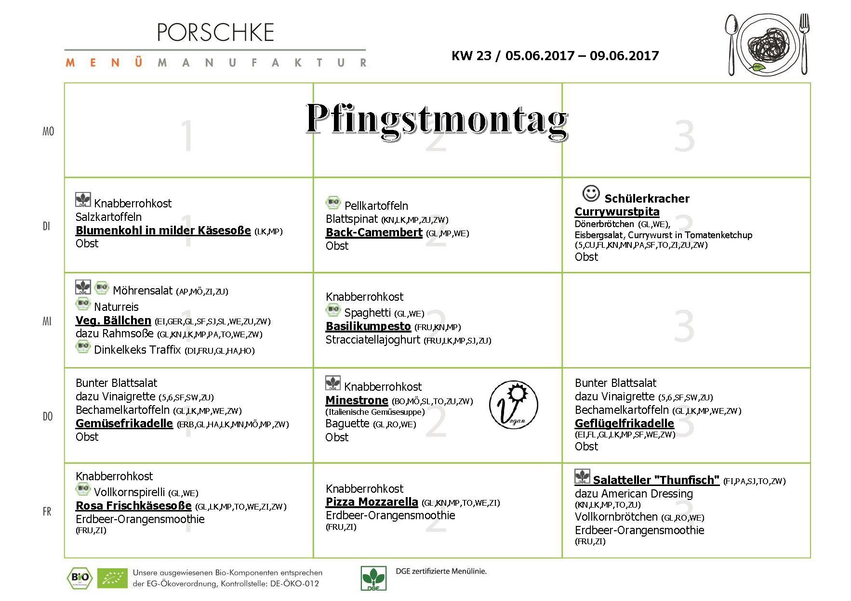

**Speiseplan-Spezial – KW 23 / 05.06. – 09.06.2017**